EDRC Use Case 1 Section 7.2.15 Parallel Operation Required
Revision of EDRC doc:

11 | Updated to reflect comments from David Price | K Willshaw  30 March 2015

Test case spec release 1.0

As with sections 7.2.12 and 7.2.13 we are dealing with an attribute of the Activity Pumping declared in section 7.2.12 where we created an instance of the ClassOfActivity PUMPING.

We have already declared and classified the Activity of type in sections 7.2.12 and 7.2.13 so we may now classify it using the appropriate Classes of Activity

Template Name : ClassificationOfIndividual

Role Name | Role Type | Role Value
hasActivity | PossibleIndividual | Identifier of Activity declared above
hasClassifier | ClassOfIndividual | PARALLEL OPERATION  or  IN SERIES OPERATION

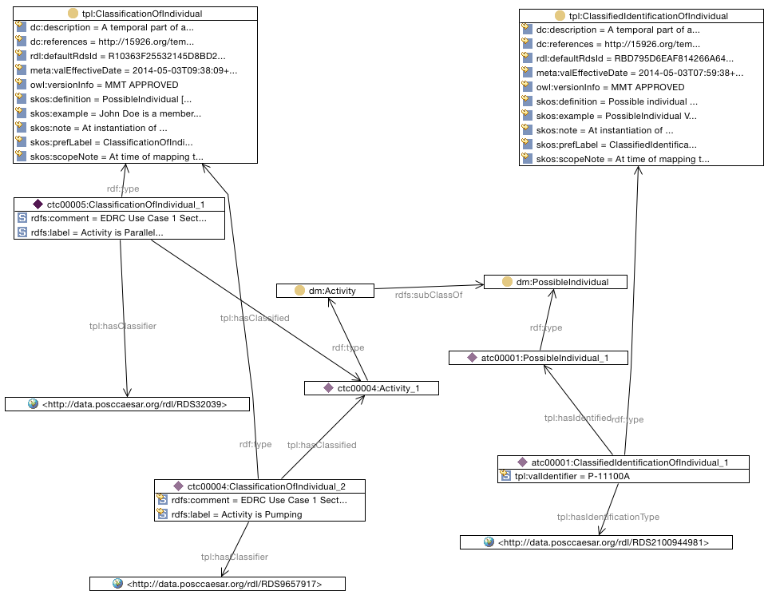

SPARQL to find Pump in PARALLEL_OPERATION

SELECT ?PumpIdentifierPumpingParallelOperation
WHERE {
?activity rdf:type dm:Activity .
?classifiedidentificationofindividual tpl:hasIdentified ?possibleindividual .
?classifiedidentificationofindividual tpl:hasIdentificationType <http://data.posccaesar.org/rdl/RDS2100944981> .
?classifiedidentificationofindividual rdf:type tpl:ClassifiedIdentificationOfIndividual .
?classificationofindividual1 tpl:hasClassified ?activity .
?classificationofindividual1 tpl:hasClassifier <http://data.posccaesar.org/rdl/RDS9657917> .
?classificationofindividual1 rdf:type tpl:ClassificationOfIndividual .
?possibleindividual rdf:type dm:PossibleIndividual .
?classificationofindividual tpl:hasClassified ?activity .
?classificationofindividual tpl:hasClassifier <http://data.posccaesar.org/rdl/RDS32039> .
?classificationofindividual rdf:type tpl:ClassificationOfIndividual .
?classifiedidentificationofindividual tpl:valIdentifier ?PumpIdentifierPumpingParallelOperation .
}

